BG4102 Medical Device Design Instructions

1. Switch on both switches by the side of the device.

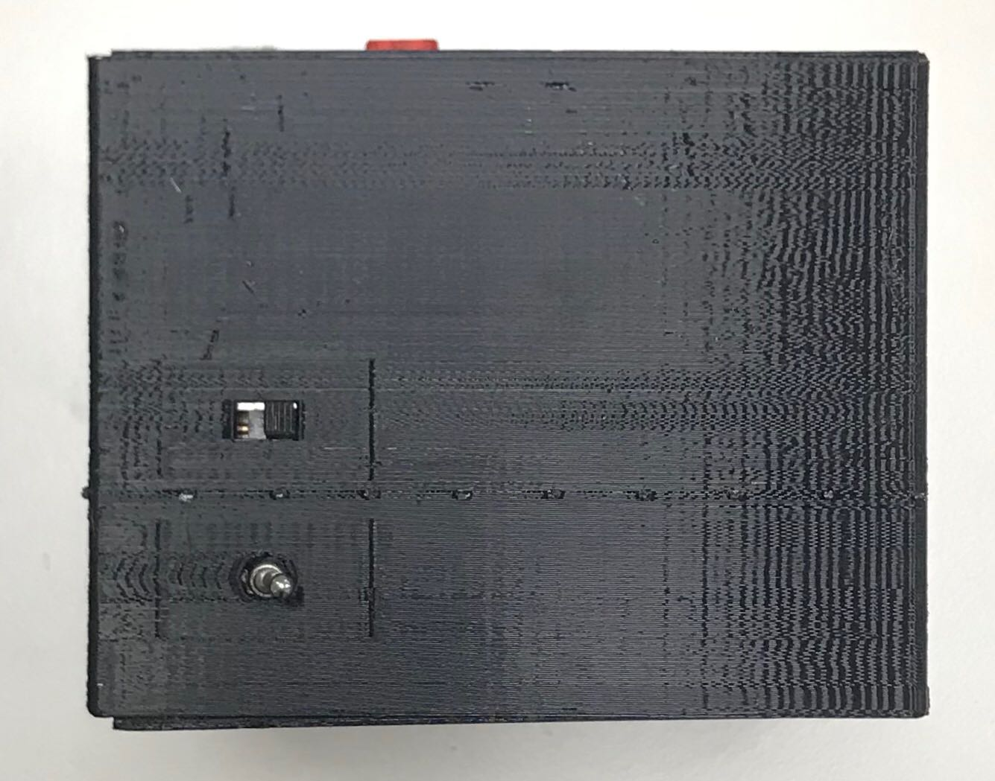

Switches are off

1. Connect device to a phone’s hotspot or router.
2. Place finger on the device.

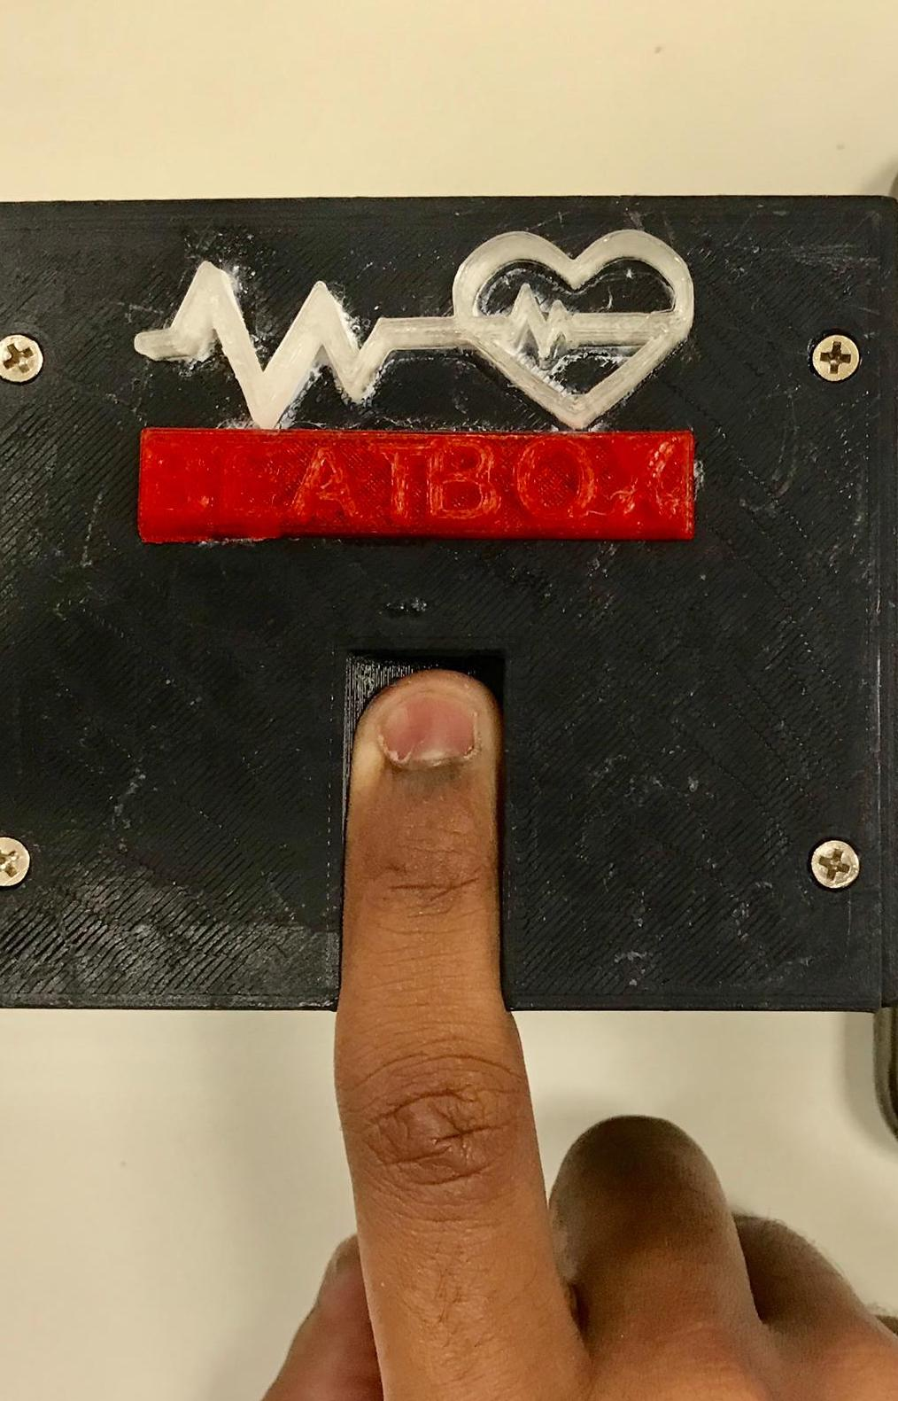

1. Type commands for the device to start running. The user needs PPG.pem in order to access the server. The key can be found in <https://github.com/pehxunwei/BeatBox>

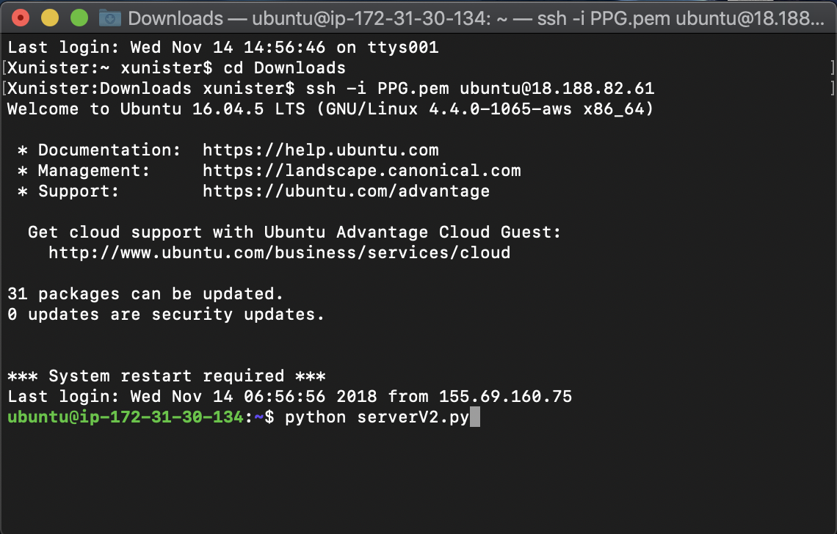

1. Let the finger rest on the device to record the data.
2. Data will be shown on the app. You may access the app through the QR code.



P.S. The device is just a prototype, please do not be alarmed when you open the device. The two cables are used to connect to the oscilloscope.

